Manipulating CSS classes using Javascript

<https://www.digitalocean.com/community/tutorials/how-to-modify-attributes-classes-and-styles-in-the-dom>

Modifying attributes of an element, regardless of how you search for it

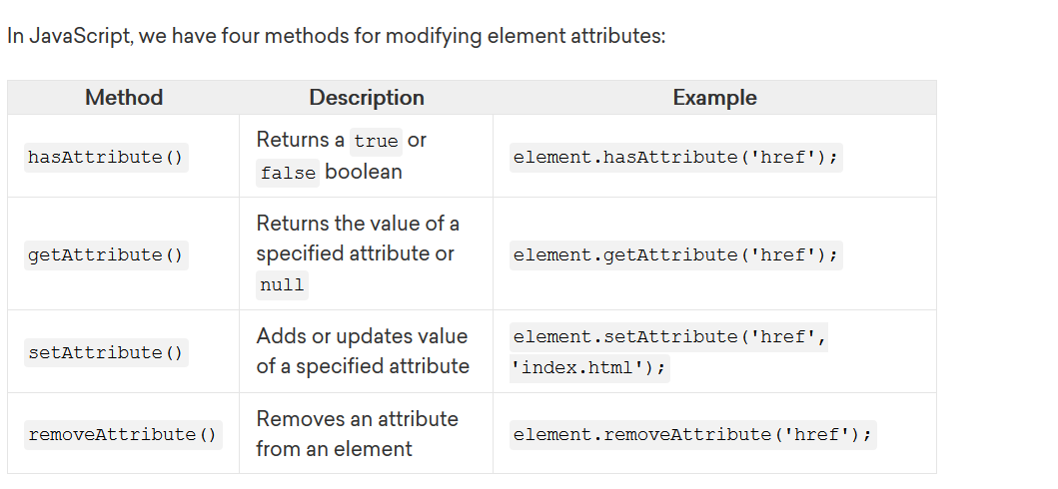

Modifying Classes (I didn’t know that could be done)

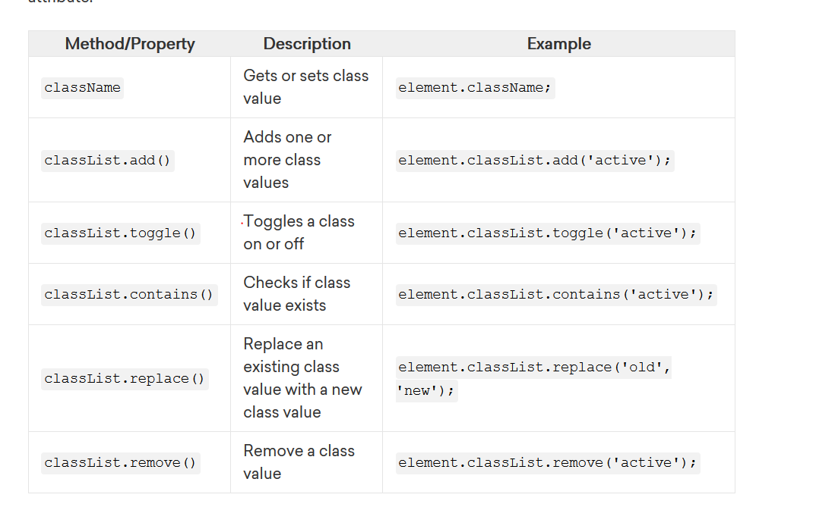

https://www.geeksforgeeks.org/change-an-element-class-javascript/